**Exercise 6.1** Draw an activity network using precedence network conventions for the project specified in Table 6.1. When you have completed it, compare your result with that shown in Figure 6.14

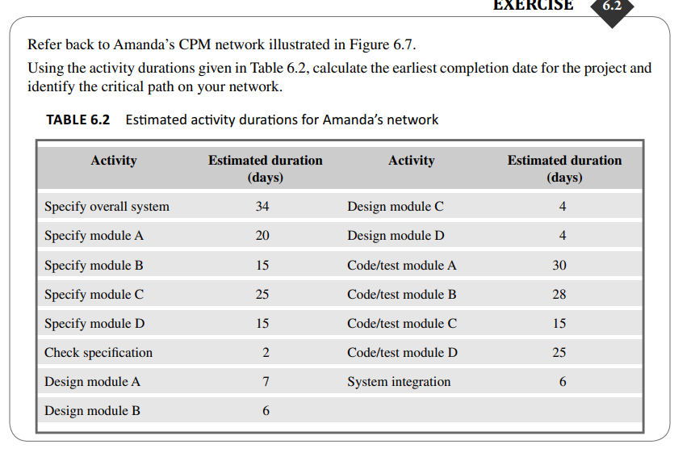

**Exercise 6.3** Calculate the free fl oat and interfering fl oat for each of the activities shown in the activity network (Figure 6.17).

**Exercise 6.4** Referring to Figure 6.17, suppose that the duration for activity F is shortened to 8 weeks. Calculate the end date for the project. What would the end date for the project be if activity F were shortened to 7 weeks? Why?

**Exercise 6.5** Take a look at the networks in Figure 6.22. State what is wrong with each of them and, where possible, redraw them correctly

